

MINI PROJECT REPORT

ON

HOSPITAL APPOINTMEMT BOOKING

Submitted by
SriyapuReddy Venkata Sai Nihar Reddy
NC.AI.U4AID25041

For
23AID101-Computational thinking
I Semester
B.Tech. AID

Department of Artificial Intelligence and Data Science
School of Computing
Amrita Vishwa Vidyapeetham, Nagercoil

1. Introduction
In today’s fast-paced world, healthcare accessibility and convenience have become vital aspects of patient care. Traditional hospital appointment systems often require patients to visit hospitals physically or make phone calls to book consultations, which can be time-consuming and inefficient. To overcome these limitations, the Hospital Appointment Booking System aims to digitalize and automate the appointment scheduling process, providing a smooth and user-friendly experience for both patients and hospitals.
This system allows users to book appointments with doctors at their preferred hospitals through an online platform. Patients can select their city, specify their health problems, and receive a list of recommended hospitals or specialists accordingly. The system provides essential information such as hospital names, addresses, contact details, and specialties, enabling users to make informed decisions without hassle.
The platform is built using Python Flask for the backend, HTML/CSS for the frontend, and CSV files or databases for data management. Flask enables efficient routing, form handling, and template rendering, making the web application dynamic and responsive. The user interface is designed to be intuitive, ensuring accessibility even for users with minimal technical knowledge.
By integrating city-based and specialty-based filtering, the system personalizes hospital recommendations, making it easier for patients to find the right healthcare provider. This not only saves time but also helps hospitals manage patient appointments more effectively. Furthermore, the system can be extended to include features like doctor availability, online consultations, appointment confirmations via email or SMS, and patient record management.
Overall, the Hospital Appointment Booking System represents a step toward the digital transformation of healthcare services. It enhances the efficiency, transparency, and accessibility of hospital appointments, improving the overall healthcare experience for both patients and medical professionals.

2. Problem Statement
In most hospitals and clinics today, patients still rely on manual or semi-digital methods to book appointments. This traditional process often requires patients to physically visit hospitals or make repeated phone calls to confirm doctor availability. As a result, patients face long waiting times, communication delays, and a lack of transparency regarding doctor schedules and hospital specialties.
Moreover, hospitals struggle to manage patient flow efficiently, leading to scheduling conflicts, overbooked slots, and underutilized resources. In many cases, patients are unaware of which hospitals or specialists are best suited for their specific health issues, especially when they are in a new city or seeking specialized care.
There is a pressing need for a digital platform that can automate and simplify this entire process — allowing patients to easily search for hospitals based on their city and medical needs, view relevant details such as specialties and contact information, and book appointments seamlessly.
The Hospital Appointment Booking System is designed to address these issues by providing an easy-to-use, web-based interface where patients can quickly find and book appointments with appropriate hospitals, thereby reducing waiting time, improving hospital resource management, and enhancing the overall healthcare experience.

3. Objectives
The main objective of the Hospital Appointment Booking System is to develop a user-friendly web application that simplifies and digitizes the hospital appointment scheduling process for both patients and hospitals.
The system is designed with the following specific objectives:
- To automate appointment scheduling:
Enable patients to book hospital appointments online without the need for physical visits or phone calls.
- To recommend hospitals based on patient needs:
Provide hospital suggestions according to the patient’s city and health problem (specialty or department).
- To create a centralized hospital database:
Maintain hospital details such as name, city, specialty, address, and contact number in a structured format using a CSV database.
- To improve accessibility and convenience:
Allow users to access the system from anywhere at any time using a web browser.
- To enhance hospital resource management:
Help hospitals manage patient flow effectively by reducing overcrowding and scheduling conflicts.
- To provide an intuitive user interface:
Design simple and clear web pages (Home, Book Appointment, Recommendations, Confirmation) for easy navigation, even for beginners.
- To use Python Flask for backend development:
Implement the application using Flask, HTML, CSS, and Pandas for smooth integration between user input, data processing, and output rendering.

4. BLOCK DIAGRAM
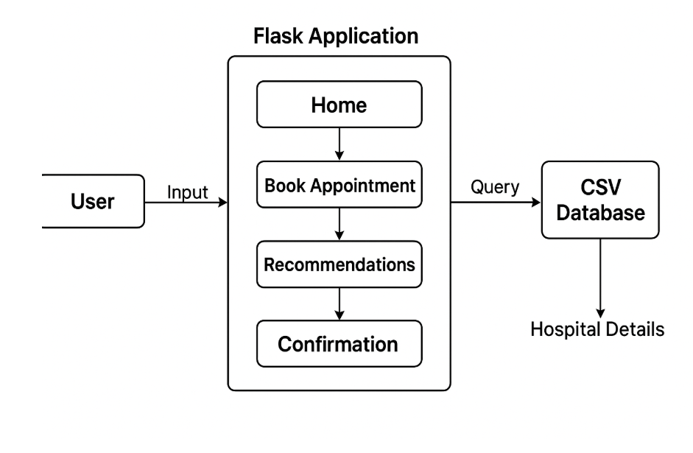

5.Modules of the Project

1. User Interface Module
- Purpose:
Provides an easy-to-use front end where users can interact with the system through web pages.
- Functions:
  - Displays the homepage, booking form, and recommendation results.
  - Collects user inputs such as name, city, and health problem.
  - Shows recommended hospitals and confirmation details.
- Technologies Used: HTML, CSS, Bootstrap, Jinja2 Templates.

2. Hospital Data Module
- Purpose:
Stores and manages hospital-related data such as names, locations, specialties, and contact details.
- Functions:
  - Loads data from a CSV file (hospitals.csv) using Pandas.
  - Provides structured access to hospital details for filtering and recommendation.
- Technologies Used: Python (Pandas Library), CSV File.

3. Appointment Booking Module
- Purpose:
Handles the process of booking an appointment based on the user’s health concern and city.
- Functions:
  - Accepts user details via an HTML form.
  - Submits data to the backend Flask application for processing.
  - Displays confirmation once the user proceeds with a selected hospital.
- Technologies Used: Flask, HTML Forms.

4. Hospital Recommendation Module
- Purpose:
Suggests the most relevant hospitals based on user input.
- Functions:
  - Filters the hospital dataset according to city and specialty (health problem).
  - Returns a list of matching hospitals with contact information.
  - Displays "No hospitals found" if there are no matches.
- Technologies Used: Python (Pandas filtering), Flask routing, Jinja2 Templates.

5. Flask Backend Module
- Purpose:
Serves as the core processing engine that connects the front end with the database.
- Functions:
  - Handles routing for pages like Home, Book Appointment, Recommendations, and Confirm.
  - Manages data flow between templates and backend logic.
  - Runs the Flask web server for handling HTTP requests.
- Technologies Used: Flask (Python Web Framework).

6. Confirmation Module
- Purpose:
Provides final confirmation of appointment details to the user.
- Functions:
  - Displays the selected hospital name, user name, city, and problem.
  - Acts as the final step before completing the booking process.
- Technologies Used: HTML, Flask (render_template).
6. Codes:
Front End:
- Static:
- Style.css:
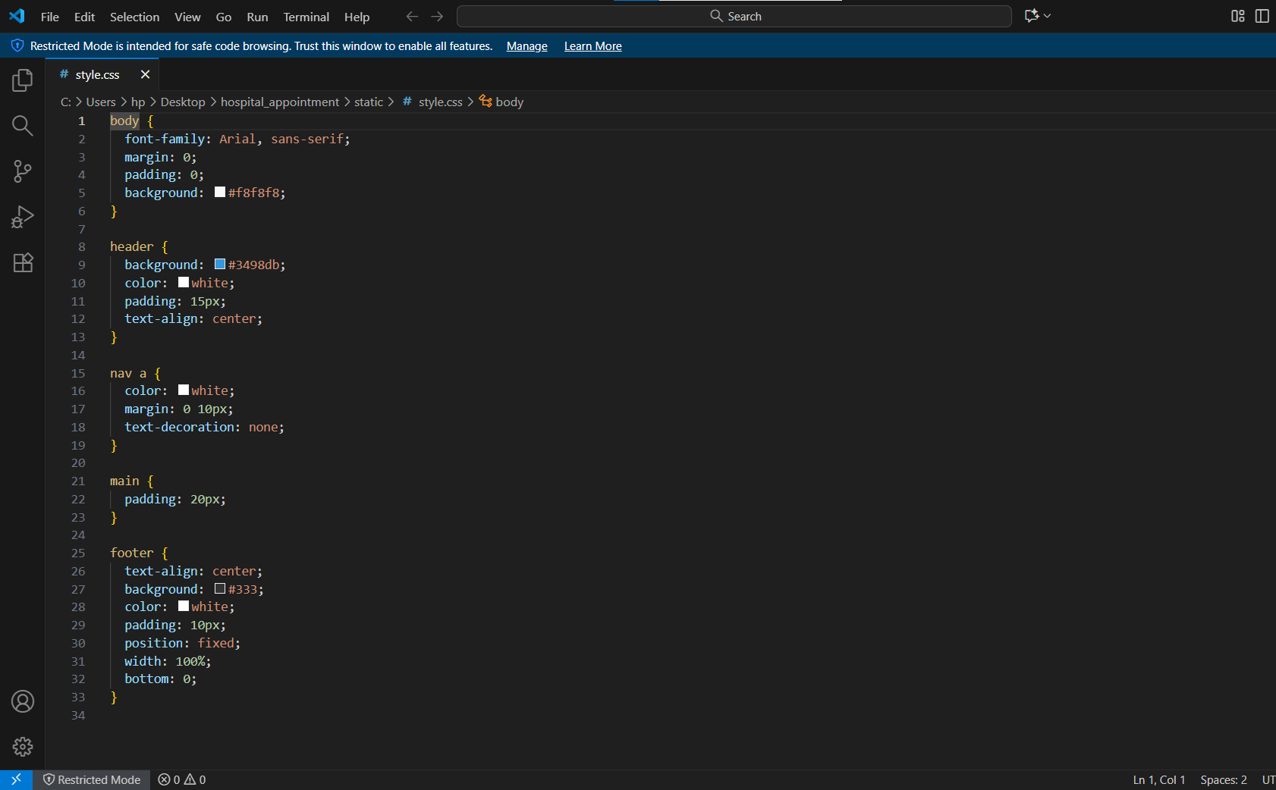

- Templates:
- Base.html
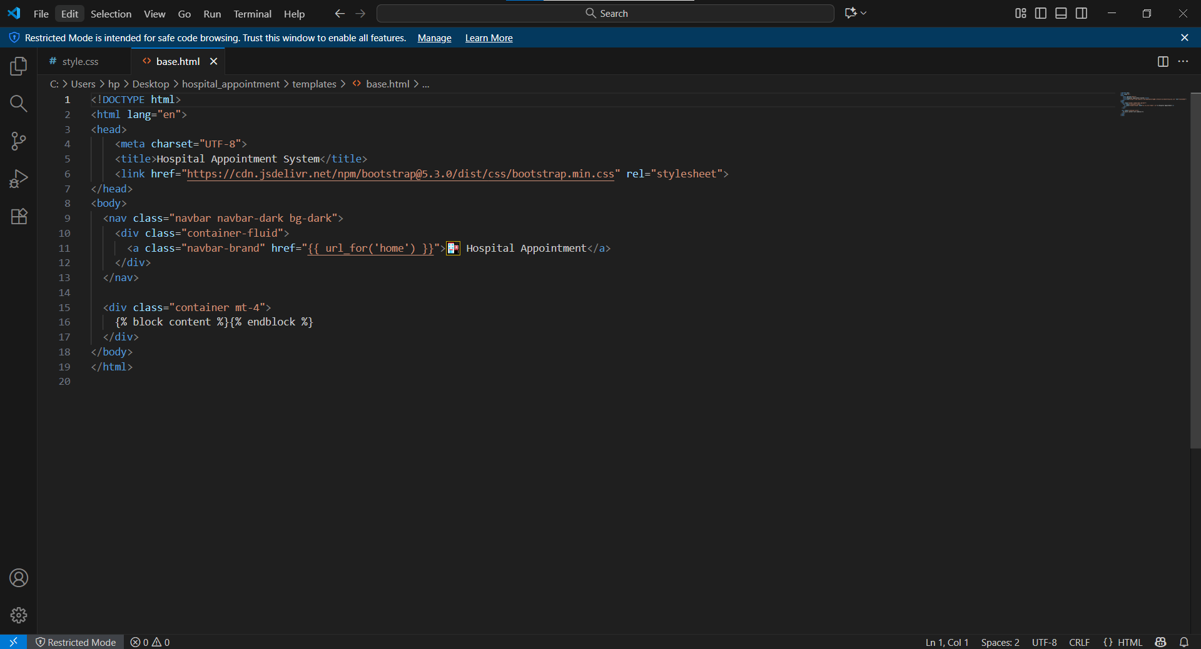
- Booking.html
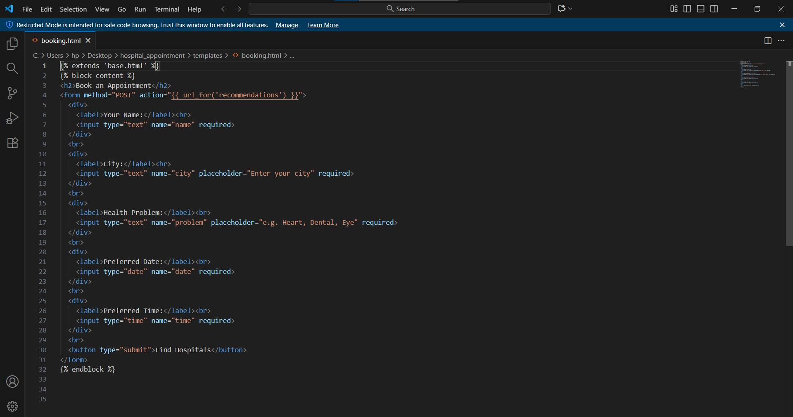

- Confirm.html
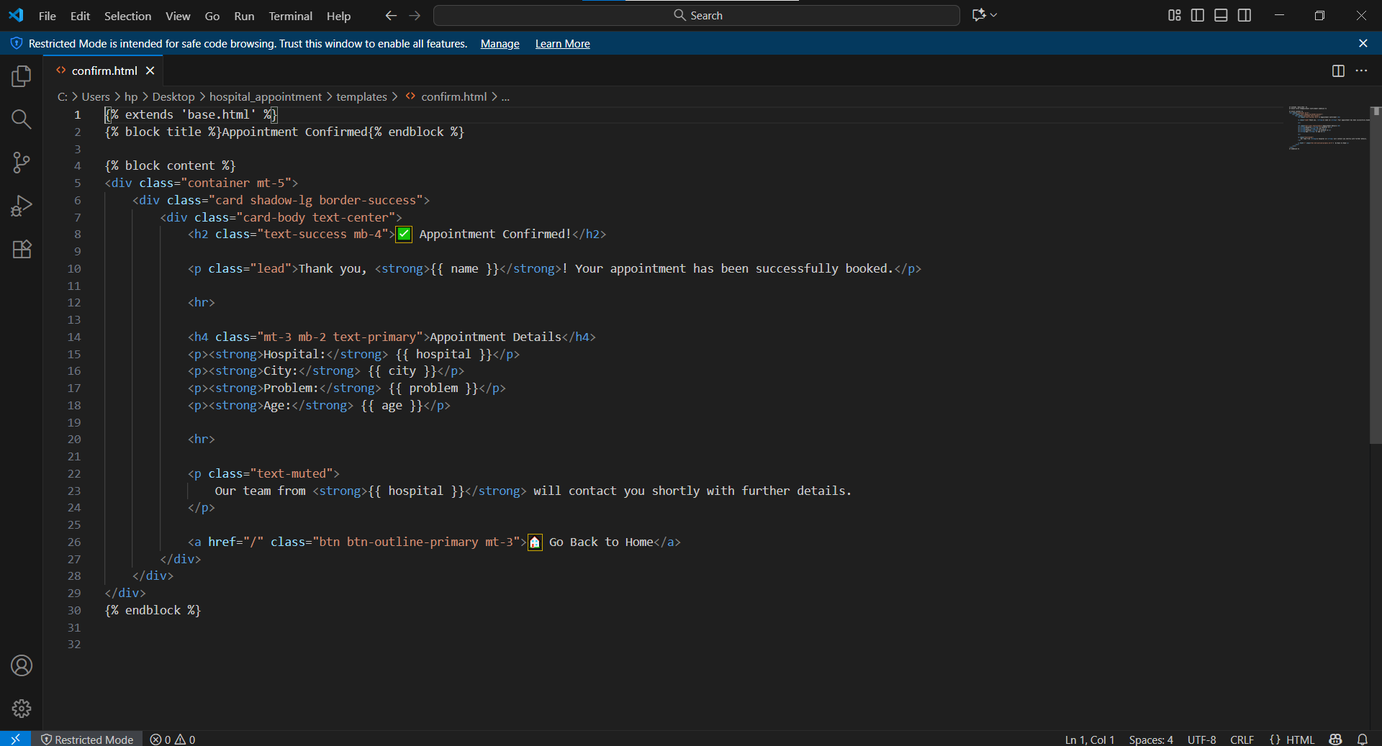

- Home.html
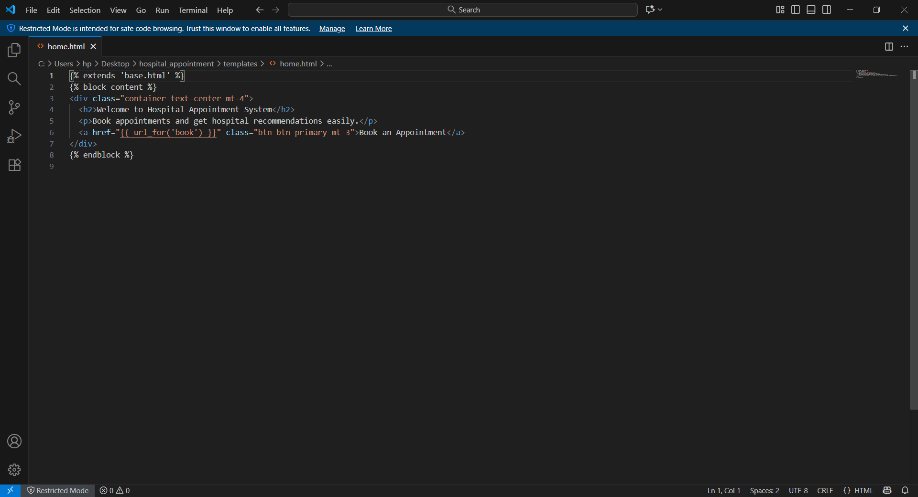
- Recommendations.html
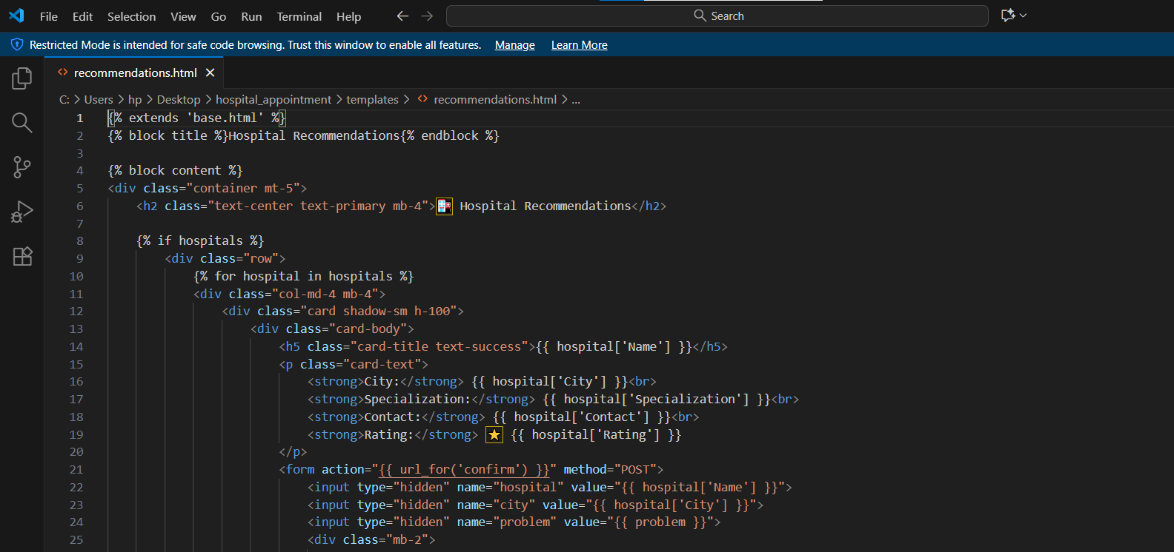

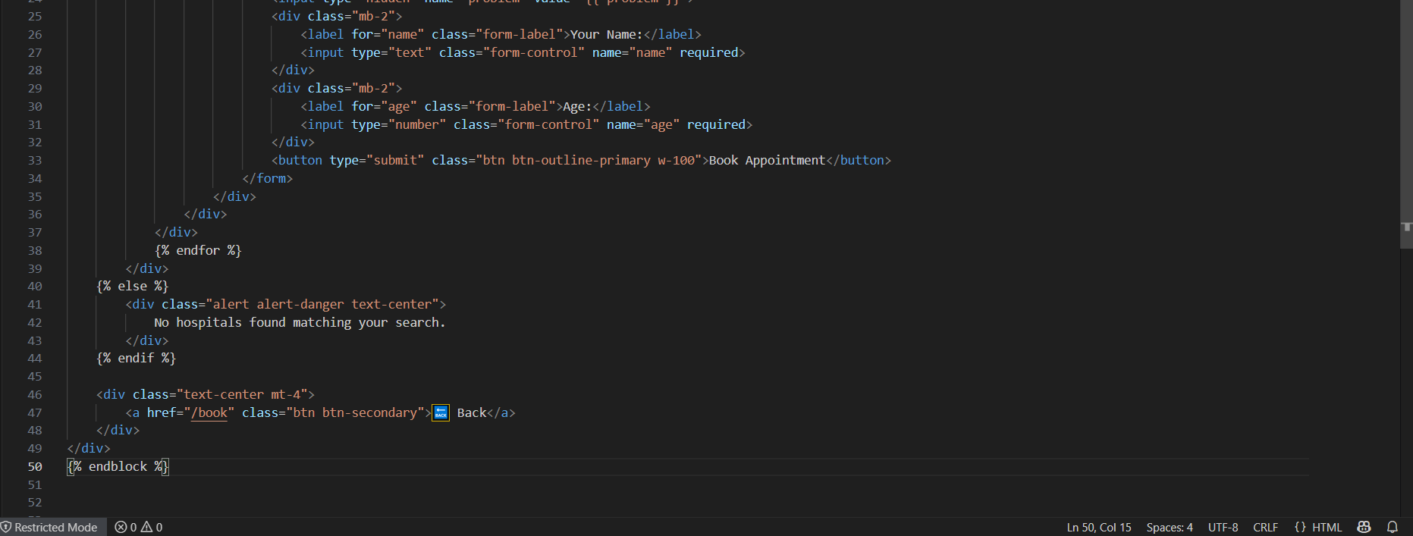

- App.py:
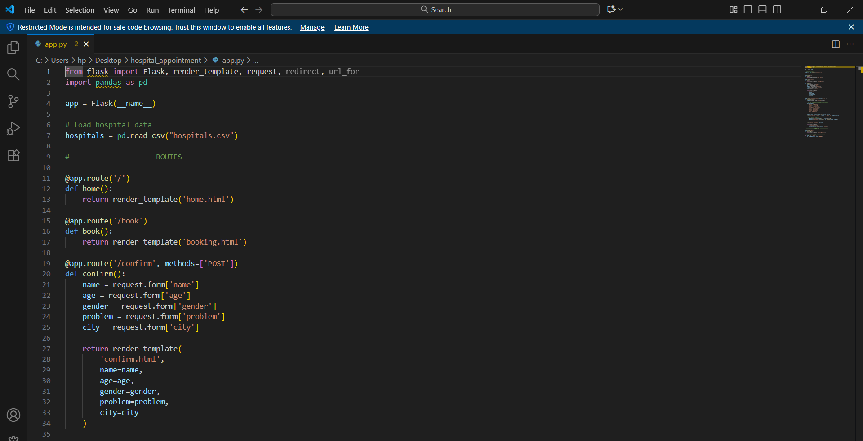
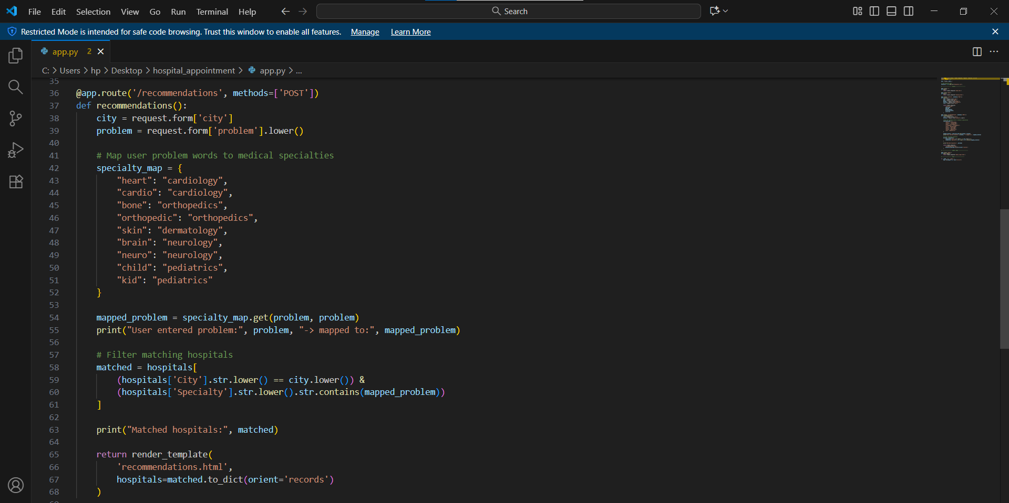
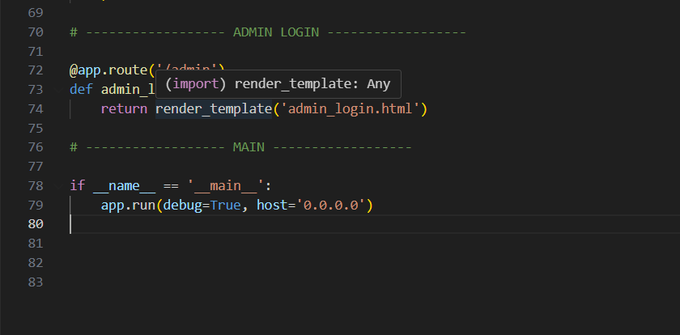

- Hospitals.csv:

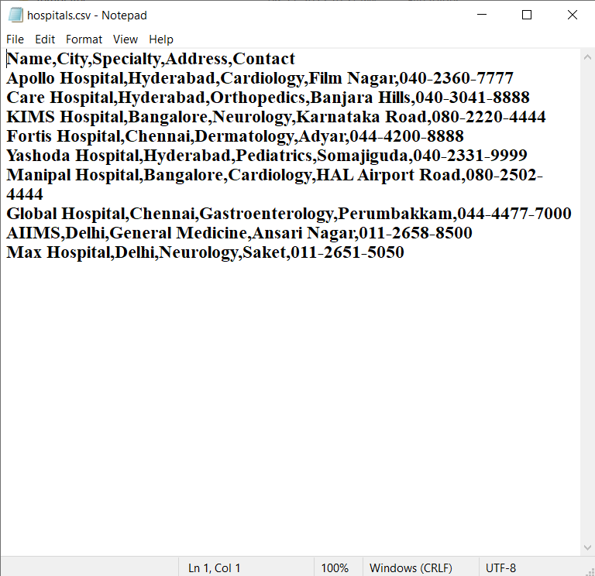

7.Running code in terminal:
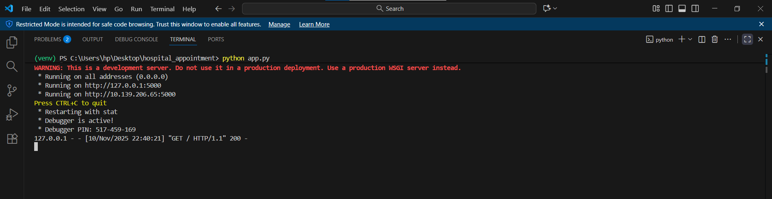

8.Output:

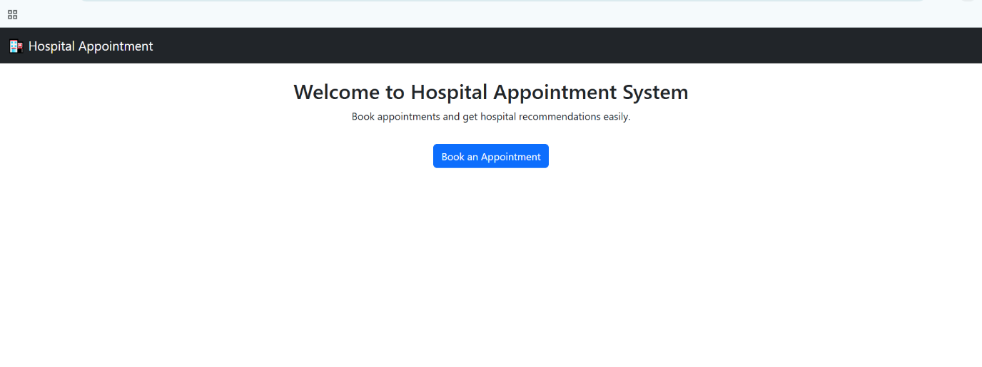

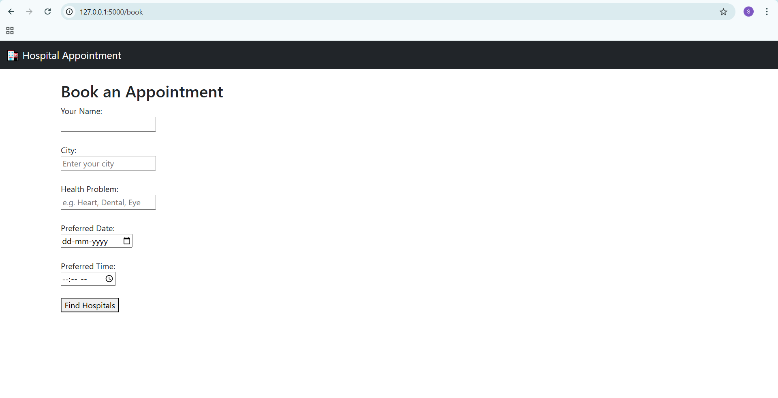

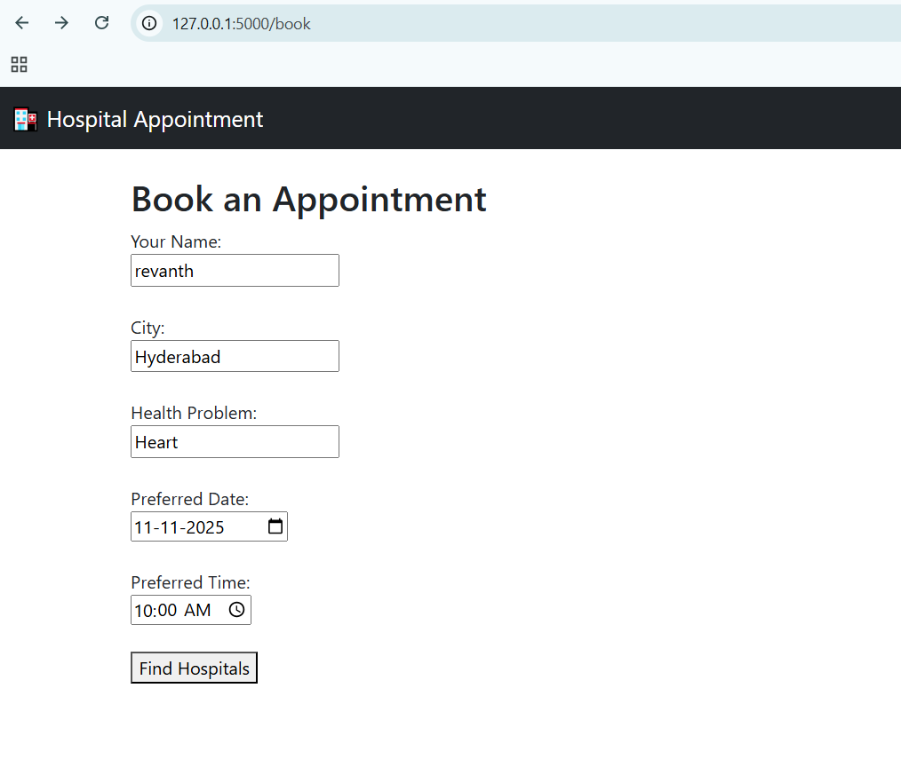
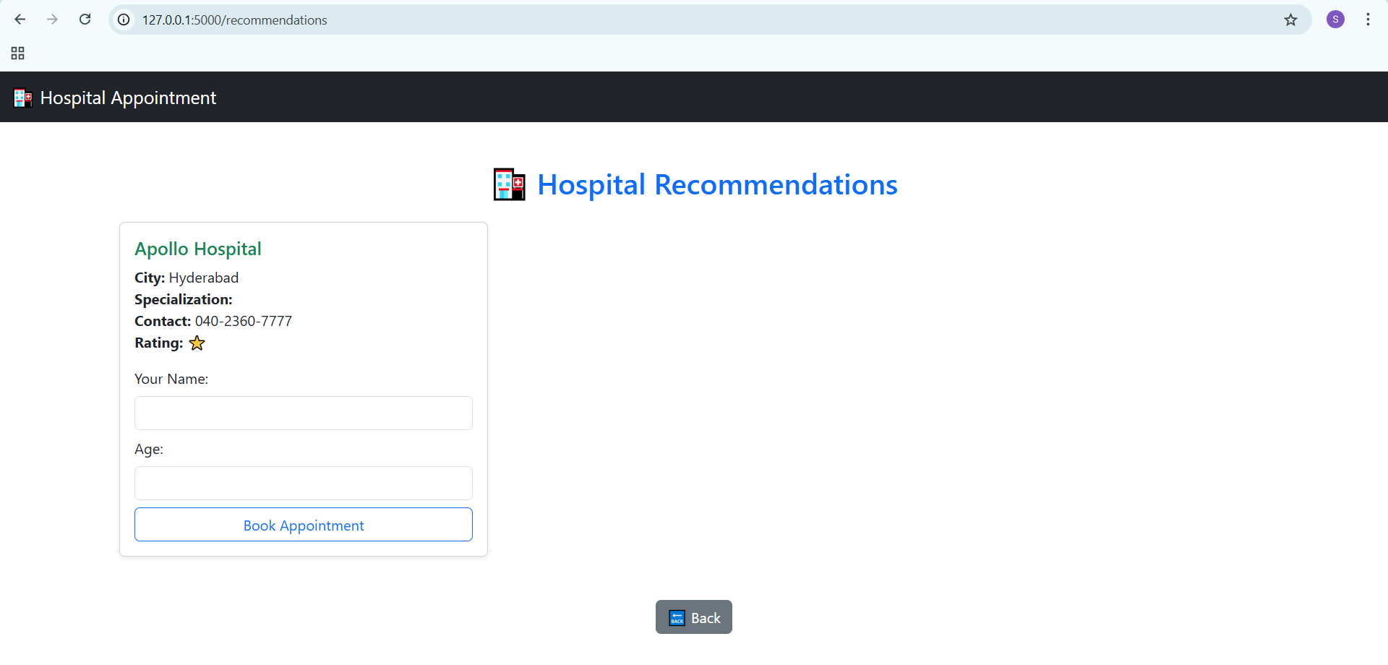
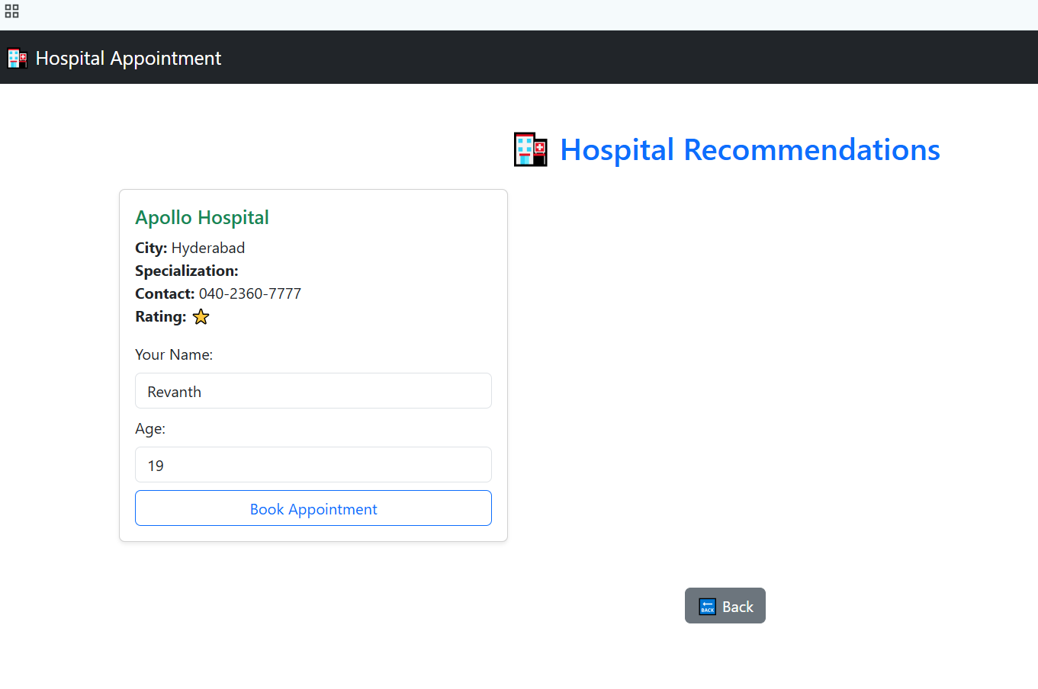

9.Applications of the Project

1. Hospitals and Clinics
- The system can be integrated into hospitals and clinics to automate the appointment scheduling process, reducing manual effort and improving efficiency.
- It helps medical staff manage patient flow and reduce overcrowding in waiting areas.

2. Patients
- Patients can book appointments easily from home, saving time and effort compared to visiting hospitals in person.
- The system provides hospital recommendations based on the city and health issue, helping users find the most suitable healthcare facility quickly.

3. Healthcare Management Systems
- The project can serve as a module in larger healthcare management software, enabling seamless coordination between patients, doctors, and hospitals.
- It improves data accessibility and decision-making in hospital administration.

4. Government and Public Health Departments
- Government health departments can use similar systems to collect data on healthcare demand, popular specialties, and hospital service coverage in different regions.
- It can help in planning healthcare resources effectively.

5. Telemedicine and Online Consultation Platforms
- The appointment booking logic can be extended to telemedicine applications, allowing patients to schedule online consultations with doctors.

6. Educational and Research Institutions
- The project can be used as a learning and demonstration tool for students studying software development, web applications, and healthcare systems.

10.Limitations of the project

The Hospital Appointment Booking System also has certain limitations that can affect its performance and usability. One of the major limitations is the dependence on internet connectivity — users in remote or rural areas with poor network access may find it difficult to use the online booking features effectively. Another limitation is the limited accuracy of hospital recommendations, as the system’s suggestions are based on predefined data and may not always reflect real-time hospital availability or specialization updates.
Additionally, the system may lack integration with hospital management systems, meaning that appointment bookings might not automatically sync with the hospital’s internal schedule or doctor availability, leading to possible overlaps or booking conflicts. Data privacy and security are also critical concerns, as storing patient details online requires strong encryption and secure authentication mechanisms to prevent unauthorized access or data breaches.
Moreover, the system currently does not support advanced features such as automated reminders, doctor profile verification, or online payments, which could enhance user experience. Finally, being a prototype-level project, it may require further optimization for handling a large number of users simultaneously and improving its scalability for deployment in large healthcare institutions.

Advantages
- Time-Saving:
Patients can book appointments from home without waiting in long hospital queues.
- User-Friendly Interface:
The web-based interface is simple and easy to navigate, even for beginners.
- Efficient Hospital Search:
Users can quickly find hospitals based on city and medical specialty, improving accessibility.
- Reduced Manual Work:
Automation minimizes manual entry and reduces errors in appointment scheduling.
- Centralized Data Storage:
All hospital information and user details are stored in one place for easy management.
- 24/7 Availability:
The system can be accessed anytime, offering flexibility to users.
- Environment-Friendly:
Reduces the need for paper-based appointment records and hospital registers.

Future Scope
- Integration with Hospital Databases:
Connect directly with hospital systems for real-time doctor availability and appointment confirmation.
- Online Payment Gateway:
Enable secure online payments for consultations and hospital services.
- Mobile Application Development:
Create an Android/iOS app version for better accessibility on smartphones.
- Automated Notifications:
Add SMS or email alerts for appointment confirmations, reminders, and updates.
- Patient Medical History:
Maintain a secure record of patient history and previous appointments for reference.
- Doctor Ratings and Reviews:
Allow users to rate hospitals or doctors to improve transparency and trust.
- AI-Based Recommendations:
Use AI to suggest hospitals or doctors based on symptoms and previous medical data.
- Multi-Language Support:
Provide regional language options to make the system more user-friendly for diverse populations.

11.Bibliography:
- Flask Documentation — The Python Microframework for Building Web Applications,
Available at: https://flask.palletsprojects.com
- Pandas Library — Data Analysis and Manipulation Tool for Python,
Available at: https://pandas.pydata.org
- HTML & CSS Tutorials — W3Schools Online Web Tutorials,
Available at: https://www.w3schools.com
- Bootstrap Framework — Front-End Open Source Toolkit for Web Development,
Available at: https://getbootstrap.com
- Stack Overflow — Developer Community for Code Troubleshooting and Solutions,
Available at: https://stackoverflow.com
- GeeksforGeeks — Flask and Web Application Development Tutorials,
Available at: https://www.geeksforgeeks.org
- Python Official Documentation — Comprehensive Guide for Python Programming Language,
Available at: https://docs.python.org
- Real Python — Learning Resources for Flask and Python Web Apps,
Available at: https://realpython.com
- Research Paper: Online Appointment Scheduling System for Healthcare —
International Journal of Advanced Computer Science and Applications (IJACSA), 2021.
- TutorialsPoint — Flask Framework and Database Integration Guides,
Available at: https://www.tutorialspoint.com

